Feedback:
- Do we make it more explicit that a catastrophic leak assumes full volume?
- Review text for flammable slow leak. Is it clear enough?
- Potential for gas calc training – in person.
- Consider mixed gases if possible.
- Information on storage of dry ice.
- Information on mixed gases and travel as a plume.

Gas/Cryogen Safety Calculator: Training Scenarios & Solutions

Part 1: Test Scenarios
Scenario 1: Compressed Gas (Asphyxiant)
You have a compressed nitrogen cylinder (an asphyxiant) with an initial pressure of 230 bar and a cylinder water capacity of 50 Litres.
The room you are storing it in has a free air volume of 100 m³.
- What is the total volume of gas in the cylinder?
- What would the resulting room O₂ concentration be in the event of a total release?
- What would the O₂ concentration be within a person's immediate "Personal Bubble" (a 12 m³ zone)?
Scenario 2: Liquefied Gas (Toxic)
You are working with a 10 kg cylinder of liquefied toxic gas (weight of contents only). The specific volume of the gas is 1.4 m³/kg. The room volume is 50 m³, but you have a lot of equipment and benches but don’t know the exact free air volume.
- What is the calculated gas volume?
- What is the final room concentration in parts per million (ppm)?
Scenario 3: Cryogenic Vessel (Asphyxiant)
You have a dewar containing 25 Litres of Liquid Nitrogen (LN₂).
The room has a free air volume of 150 m³.
- How many cubic metres of gas will this generate if fully released?
- According to the calculator's thresholds, what is the resulting room O₂ concentration, and what specific recommendation/warning does the calculator provide for this level?
Scenario 4: Known Volume (CO₂ Enrichment)
You are venting a known volume of 1.5 m³ of Carbon Dioxide into a room with a free air volume of 40 m³.
- What is the room concentration of CO₂ as a percentage?
- Based on the calculator's thresholds, is fixed CO₂ detection required?
Scenario 5: Slow Leak (Flammable)
A faulty regulator causes a continuous "Large Leak" of a flammable gas. The room is 80 m³ and the ventilation system provides 6 Air Changes per Hour (ACH).
- What will the steady-state concentration of the gas in the room be as a percentage?
Scenario 6: Toxic Gas, External Lookups & Detection Placement
You are planning to store a BOC size 'AV' cylinder of compressed Carbon Monoxide (CO) at an initial pressure of 51 bar. The room has a free air volume of 80 m³.
- You'll need to look up the water capacity of a standard BOC size 'AV' cylinder to calculate the total gas volume. What is the calculated gas volume?
- What is the resulting room concentration in parts per million (ppm) if the entire cylinder vents?
- Look up the standard Workplace Exposure Limit (WEL) for Carbon Monoxide in the HSE's EH40 document (or reference the calculator's internal guidance). Based on that, is detection required?
- According to the calculator's methodology report, what specific type of detector should you use for this gas, and at what height should it be mounted?
Scenario 7: Slow Leak, Time to Hazard & Heavy Gas Detection
A regulator on a Carbon Dioxide (CO₂) system has failed, resulting in a continuous "Medium Leak" in a small 20 m³ preparation room. The room currently has active ventilation providing 2 Air Changes per Hour (ACH).
- Using the calculator's leak rate guidance, what is the steady-state CO₂ concentration in the room as a percentage?
- Suddenly, the building's ventilation system completely fails (0 ACH worst-case scenario). Using the calculator's "Time to Hazard" formula for CO₂, how long will it take for the room to reach the 0.5% detection threshold?
- According to the calculator's guidance, what specific type of sensor must be used for CO₂, and how high off the floor should it be mounted?

Scenario 8: Mixed Gas Cylinders & Multiple Independent Risks
You are using a standard BOC size 'L' cylinder of a mixed gas comprising 10% Carbon Dioxide, 10% Hydrogen, and 80% Nitrogen (Balance). The initial pressure is 200 bar. The cylinder is located in a small 30 m³ instrument room.
- Visit the BOC website to locate the details of the cylinder. Look for the water capacity of the cylinder in L.
- When assessing mixed gases in the calculator, you must assess each component gas independently. First, what is the total volume of gas in the cylinder?
- Next, calculate the individual gas volumes for the CO₂ (10% of total) and Hydrogen (10% of total), and determine their specific room concentrations.
- Finally, calculate the total Oxygen depletion caused by the entire volume of gas displacing the room air.
- Based on these concentrations, which warning threshold is breached first in the event of a leak? Therefore, what specific detector type is the most critical to install, and are the others redundant?

Part 2: Answers & Methodology
Scenario 1: Compressed Gas (Asphyxiant)
Answers:
- Gas Volume: 11.35 m³.
- Room O₂ Concentration: 18.57%.
- Personal Bubble O₂ Concentration: 1.13%.
  - Methodology: The personal bubble assesses a fixed 12 m³ volume immediately surrounding the release point. Because 11.35 m³ replaces most of that 12 m³ air volume, the local oxygen level drops severely.
Explanation:
In this instance, we already know both the pressure the cylinder is charged to, as well as the water capacity of the cylinder. These are generally provided by the supplier of the cylinder for all compressed gas cylinders. Some will provide the volume of contents, so this step can sometimes be skipped.
In this instance, we can select:
“I have a compressed gas cylinder, but do not know the volume of the contents.”, enter the values and click “Calculate Volume” – shown in the screenshots below.
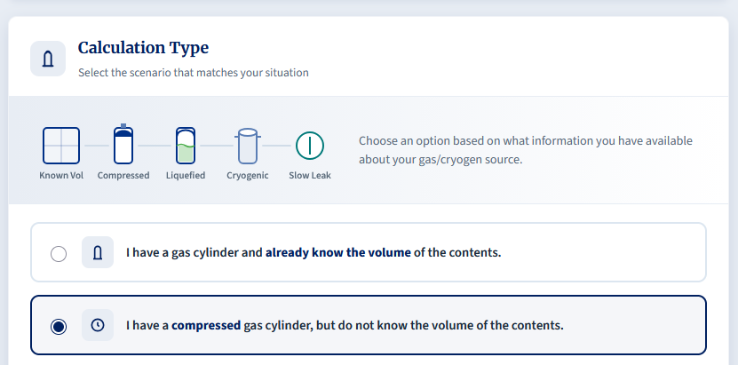
Figure 1: Select the Calculation type for a compressed gas cylinder
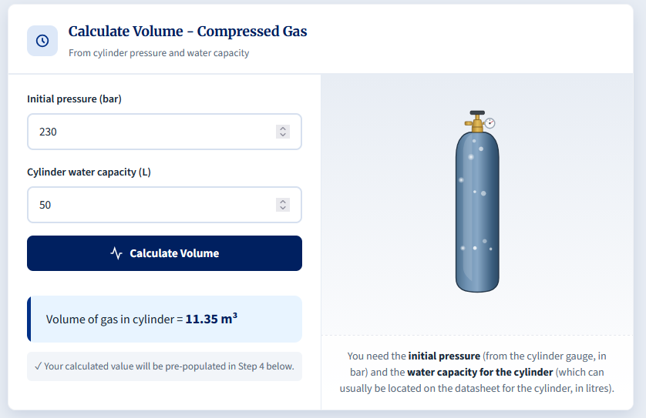
Figure 2: Enter the pressure and water capacity, and click Calculate Volume.
After clicking Calculate Volume, we are yielded a value of 11.35 m³, and this corresponds to the volume of gas within the cylinder.
After this, we continue down the calculator, where we are asked for the Free Air Volume of the room. The volume of gas it automatically populated into the relevant field for us.
We input the free air volume, and selected “Asphyxiant” as the gas hazard type.
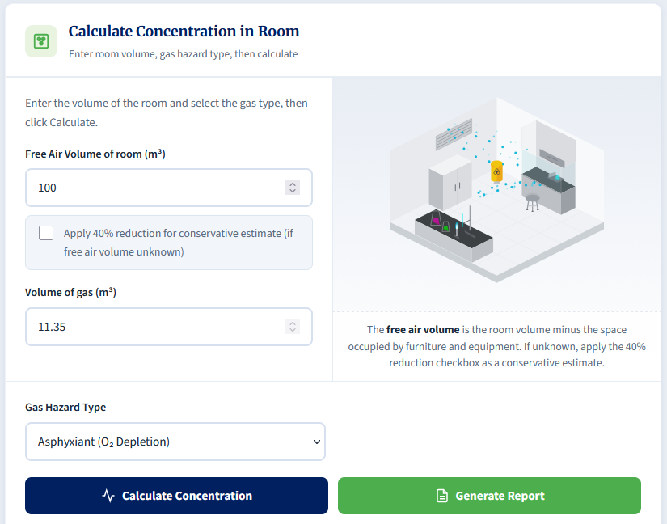
Figure 3: Enter the Free air volume, and ensure Asphyxiant is selected, before clicking "Calculate Concentration".
After this, the concentration of O2 in the room is displayed in the event of a catastrophic release.
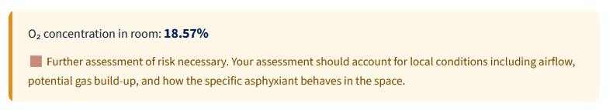
Similarly, a personal bubble calculation is automatically calculated as part of the process. This simulates the O2 concentration in a 2x2x3 bubble which contains the cylinder.
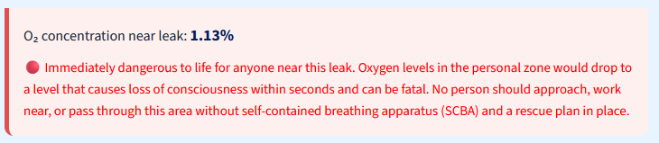
Scenario 2: Liquefied Gas (Toxic)
Answers:
- Gas Volume: 14 m³.
- Room Concentration: 466,666.67 ppm.
  - Methodology: The 40% reduction drops the 50 m³ room to an effective free air volume of 30 m³.
Explanation:
This scenario is asking us to determine the volume of gas that can be contained within a cylinder of liquefied gas. The phase of the medium is different, but we can still calculate the volume of gaseous contents that the cylinder contains.
This time, we select:
“I have a liquefied gas cylinder, but do not know the volume of the contents.”
The scenario provides us with the weight of the cylinder contents (Exercise caution, as some supplier will include the weight of the cylinder too – we just want the weight of the contents) as well as the specific volume of the gas. Specific volume will be specific to the contents of the gas and can be located by searching online. Engineering Toolbox is a good site to visit to find these, but not all can be found there.
We simply enter both the weight of contents and specific volume and click “Calculate Volume”.
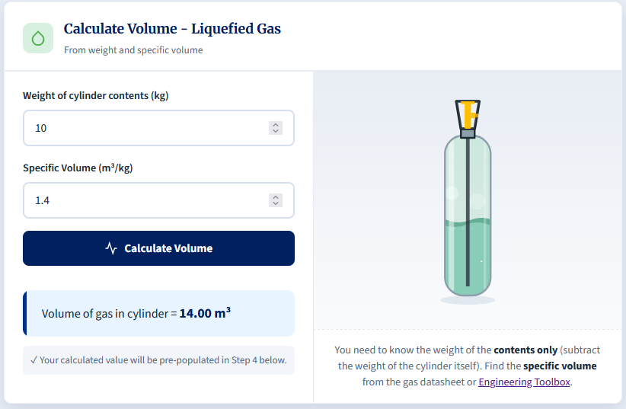
Figure 4: Enter both the cylinder contents weight and specific volume and click "Calculate Volume".
This calculation yields a result of 14 m³ of gaseous contents.
As before, we scroll further down to calculate the final room concentration of the gas during a catastrophic release.
The room volume is 50 m³, but we don’t know how full of furniture it is, so we will apply the 40% volume reduction to estimate the free air volume. Note: This is a conservative estimate, but if your room/lab is significantly cluttered then it would be valuable to look to measure the free air volume by subtracting the volume of all equipment from the volume of the room.
In this instance, we select “Toxic” as the gas hazard type, and click calculate.
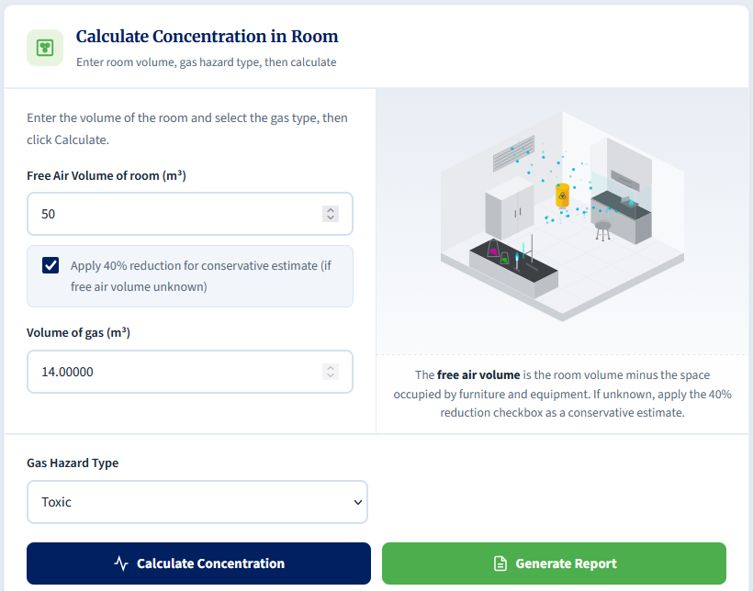
For toxic gases, a recommendation cannot be made from the calculation alone. The workplace exposure limits (WELs) for these gases varies widely, and therefore you will need to ensure you find the WEL for the gas you are using and compare it to the concentration calculated.
In this instance, a room concentration of 466,667 ppm is calculated which is likely to heavily exceed the most common WELs, and therefore controls would be needed to mitigate the risks to users in the area where the cylinder is contained.
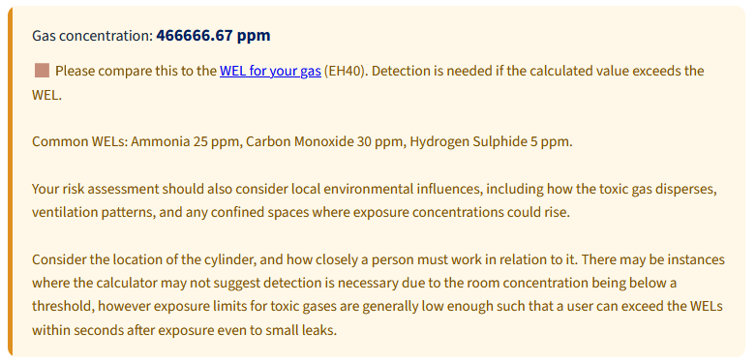
Scenario 3: Cryogenic Vessel (Asphyxiant)
Answers:
- Gas Volume Generated: 17.35 m³.
  - Methodology: Liquid Nitrogen (LN₂) expands dramatically, multiplying by an expansion ratio of approximately 694.
- Room O₂ Concentration & Recommendation: 18.53%.
  - Recommendation: The calculator categorizes levels between 18% and 19.5% as requiring further risk assessment, noting to account for local conditions, airflow, and gas build-up.
Explanation:
When cryogenic liquids heat up, they rapidly expand as they boil, creating hundreds of times the volumes of the initial liquid. This can lead to rapid creation of asphyxiation risks.
We begin by calculating the volume of the gas after expansion by selecting the option:
“I have a Cryogenic vessel (Dewar / Tank).”
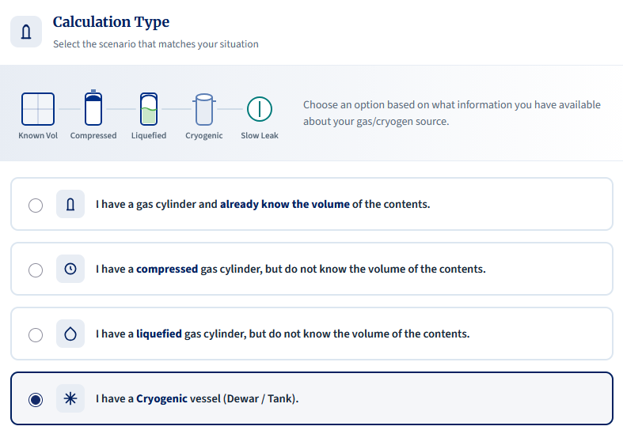
Following this, we need to select the cryogen we are using, as well as the known contents of the vessel. If in doubt, use the highest supported capacity of the vessel.
In this instance, we know it holds 25L of liquid nitrogen (LN2), so we enter that into the calculator and click “Calculate Volume”.
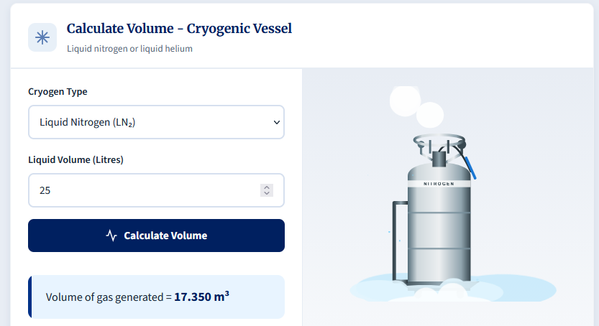
We can therefore determine that this dewar could release up to 17.35 m³ of nitrogen gas.
Scrolling down, we can then calculate the room concentration as we know the free air volume. We input that into the calculator, (the volume will be automatically input) and click “Calculate Concentration”.
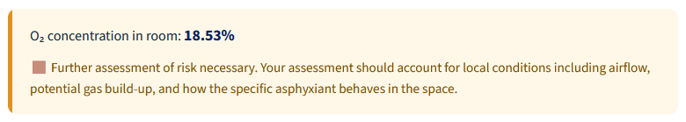
The calculator indicates further assessment of risk is necessary.
The likelihood is that with ventilation in the room, the O2 concentration, the concentration is not likely to dip into a hazardous region, but there could still be potential for localised effects to asphyxiate users should they work close to the source of the leak.
In instances like these, you should consider the hierarchy of control to ensure that the risk is eliminated/substituted as far as possible, either through use of smaller dewars (assuming the LN2 is vital), and checking that ventilation is sufficient to mitigate the residual risks. Detection is always a useful consideration to make users wary of leaks, but the need for this would be subject to risk assessment e.g. looking at whether working patterns/locations and existing controls are good enough to prevent a foreseeable event of asphyxiation.
Separately from the gas risk, the assessment must also consider effects of exposure to cryogenic liquids too.
Scenario 4: Known Volume (CO₂ Enrichment)
Answers:
- Room Concentration: 3.75%.
- Detection Required?: Yes.
  - Methodology: The calculator rules state that CO₂ detection is required if the concentration is above 0.5%.
Explanation:
In this example, we are provided with the volume of gas in the cylinder already. Some providers will provide this information up front, and it makes the calculation quite a bit easier to complete.
Knowing this, we can select the option: “I have a gas cylinder and already know the volume of the contents.”
From there, we simply enter the values from the scenario, selected Carbon Dioxide from the Gas Hazard Type dropdown, and click “Calculate Concentration”.
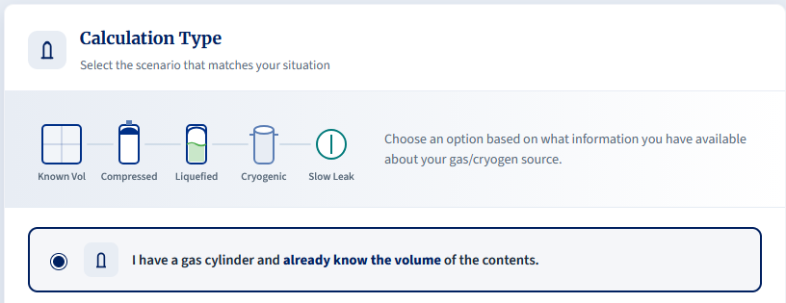
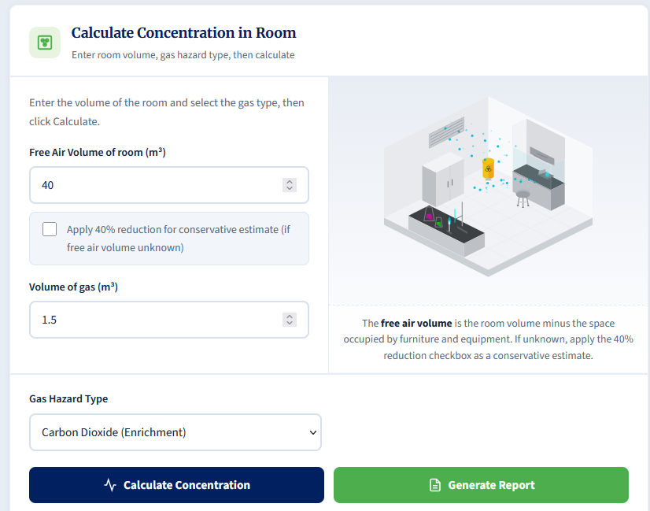
This yields a room concentration of 3.75% CO2. As indicated below, the recommendation is such that detection must be considered as this level of gas release is well above the 0.5% limit.
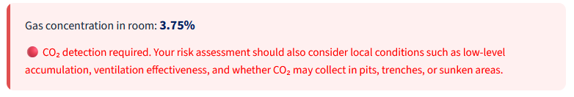

Scenario 5: Slow Leak (Flammable)
Answer:
- Leak Rate: 1.0 m³/hr.
  - Methodology: According to the Leak Rate Guidance table, a "Large Leak" is estimated at 1.0 m³/hr or greater.
- Steady-State Concentration: 0.21%.
  - Methodology: The ventilation rate is 480 m³/hr (80 m³ × 6 ACH). The steady-state concentration is (1.0 / 480) × 100.
Explanation:
Calculating the volume of a slow leak is not an exact science, and this calculator should be used with caution. If values are not known or measurable, then coming to an accurate conclusion on the risk to a person if difficult. You should avoid guessing leak rates and air changes and should prefer to measure where possible.
In this scenario, the leak rate is indicated as large, and this would coincide with a leak such as a severed hose from a regulator and would likely cause a loud hiss with frosting on any nearby equipment.
We begin by selecting the slow leak calculator:
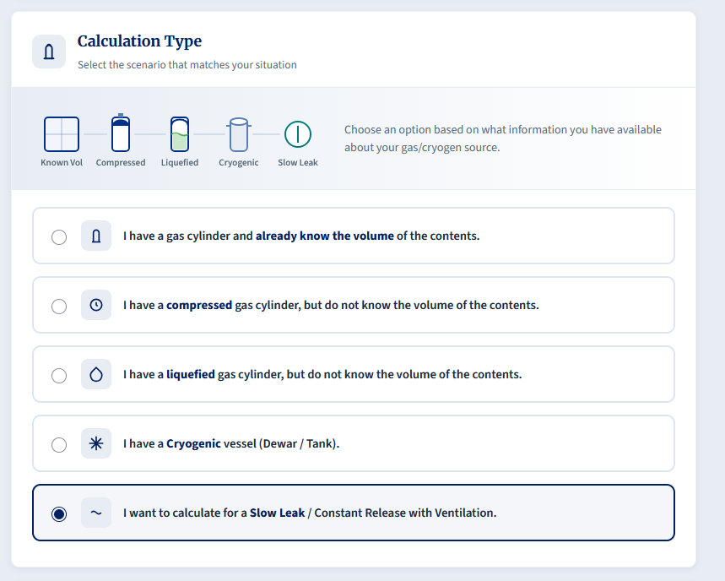
After this, we can enter all the details into the calculator. A ‘large’ leak would coincide with a volume loss on the order of 1m³/hr, so we enter this into the calculator, alongside the air changes of 6, and free air volume of 80. We then select Flammable as the Gas Hazard type and click calculate.
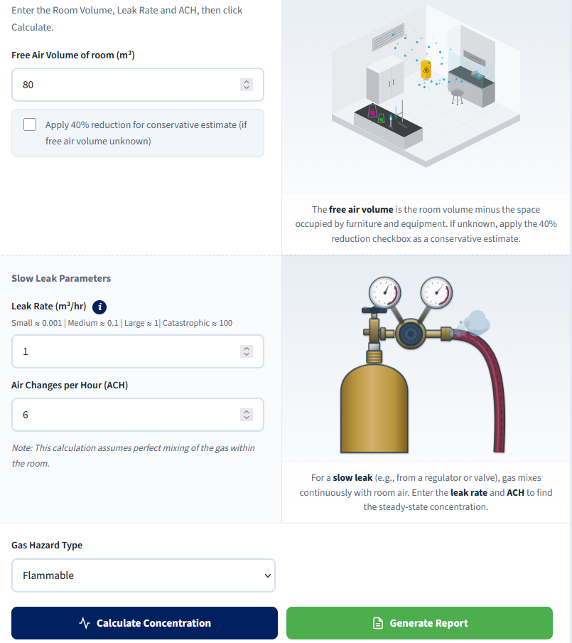
For examples where gas is being added into the room, the steady-state concentration is equal to the concentration of gas in the room, and therefore we end with a steady-state concentration of 0.21%. This is lower than the most common lower-explosive limits, and therefore detection in this scenario is unlikely to be recommended depending on proximity of work and other hazards that could exacerbate local risks.
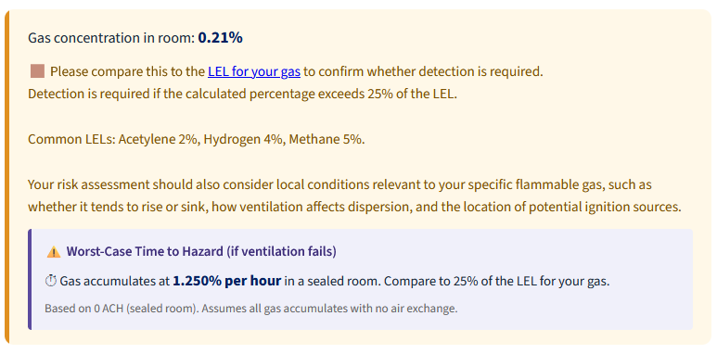
Scenario 6: Toxic Gas, External Lookups & Detection Placement
Answer:
- Gas Volume: 0.5 m³.
  - Methodology: A standard BOC size 'AV' cylinder has a water capacity of 10 Litres, and an outlet pressure of 51 bar.
- Room Concentration: 6250 ppm.
- WEL & Detection Requirement: Yes, detection is required. The internal guidance notes a common WEL for CO is 20 ppm.
- Detector Type & Placement: Electrochemical sensor, mounted at breathing zone height (approx. 1.5m - 1.8m).
  - Methodology: Toxic gases require electrochemical sensors. CO has a density similar to air, so it is mounted at typical breathing height.
Explanation:
When calculating risks from compressed gas or cryogen hazards, in reality we will likely need to search for the relevant data in order to carry out calculations. Different providers will provide different information which can make the process harder. The values you will need to locate are all provided in the guidance of the calculator.
In this instance, we know the gas is Carbon Monoxide and the cylinder is an AV cylinder from BOC. We will need to visit their website to locate the details for the cylinder.
In this instance, the site lists 500L as the capacity for an AV cylinder, which corresponds to 0.5m³ of gas.
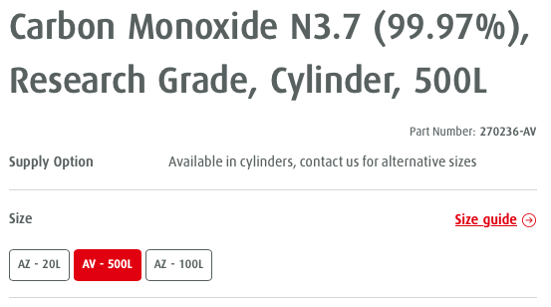
As we already know the gas volume, we can skip that calculation, and go straight to “I have a gas cylinder and already know the volume of the contents.”
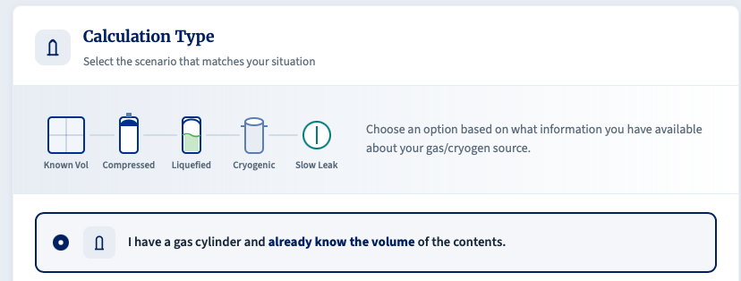
After selecting that, we enter the gas volume and free air space, as normal. We then select Toxic under the Gas Hazard Type, and then Calculate Concentration.
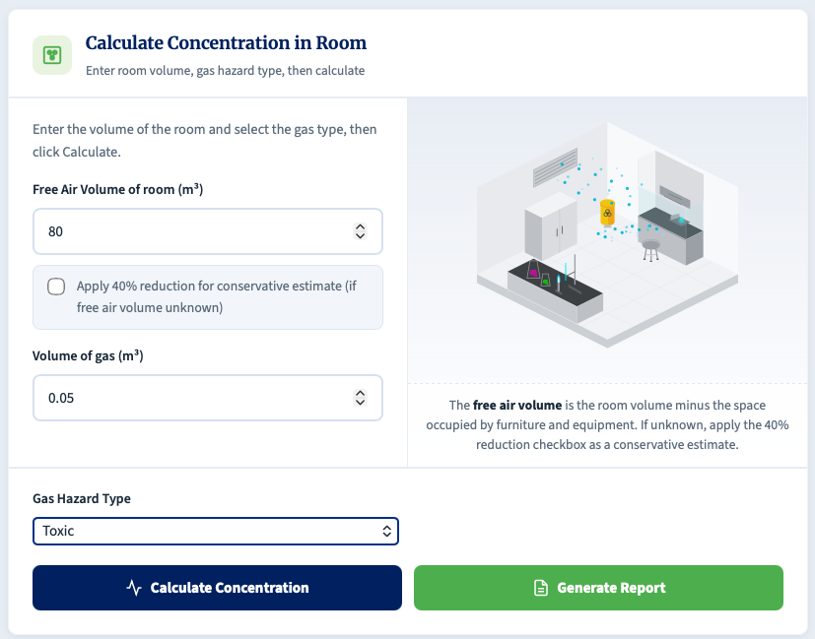
By clicking calculate, we see that the room concentration will reach 6250 ppm if there is a catastrophic release.
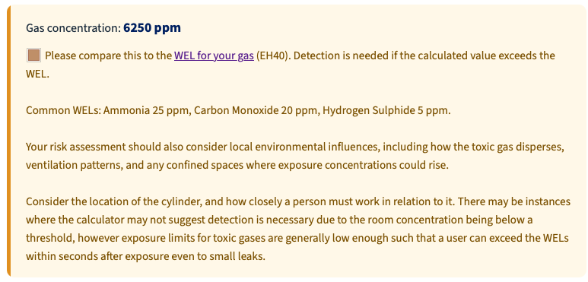
If we got to EH40 (linked in the calculation box within the calculator), we can locate Carbon Monoxide and can see that the WEL is 20ppm for the long-term exposure limit (the 30ppm underneath is a limit that applies to underground workers only).
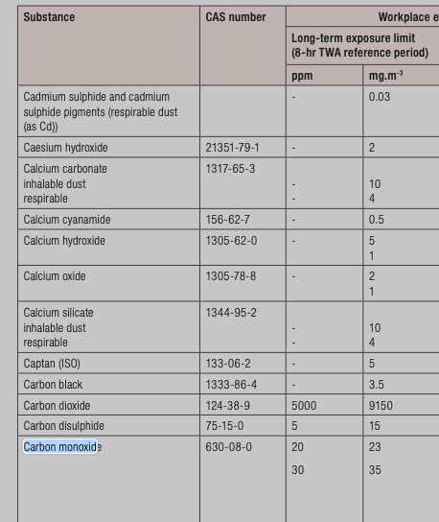
As a catastrophic release would be well over this limit (and would also be over the immediately dangerous to life/health limit (1200ppm)), detection would be recommended.
If we then click the “Generate Report” button in the calculator and scroll down, it can also provide recommendations for different types of detection as well as heights – see attached image.
In this instance, the detector to be used would be an electrochemical sensor that would detect CO, and it would ideally be mounted in the breathing zone (between 1.5m – 1.8m) as the molecular weight of the gas is similar to that of air.
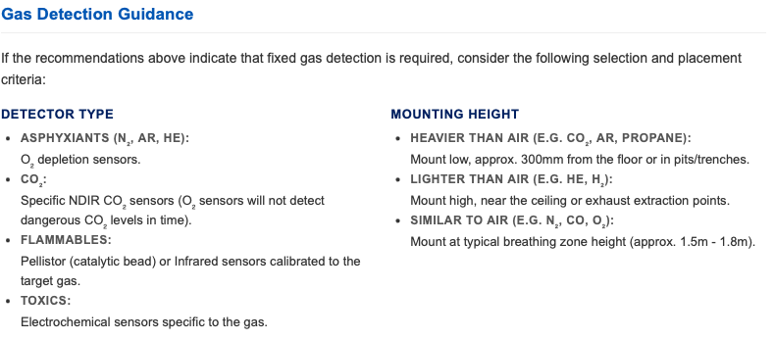
Scenario 7: Slow Leak, Time to Hazard & Heavy Gas Detection
Answer:
- Steady-State Concentration: 0.25%.
  - Methodology: A "Medium Leak" is approximately 0.1 m³/hr. The ventilation rate is 40 m³/hr (20 m³ × 2 ACH).
- Time to Hazard (to 0.5%): Approximately 1 hour.
  - Methodology: Utilizing the logarithmic accumulation formula for a 0 ACH worst-case scenario.
- Detector Type & Placement: Specific NDIR CO₂ sensor, mounted low (approx. 300mm from the floor).
  - Methodology: Standard O₂ sensors will not detect CO₂ efficiently. CO₂ is heavier than air and accumulates low.
Explanation:
As previously mentioned, calculating the volume of a slow leak is not an exact science, and this calculator should be used with caution. If values are not known or measurable, then coming to an accurate conclusion on the risk to a person if difficult. You should avoid guessing leak rates and air changes and should prefer to measure where possible.
IN this scenario, we know the gas, the size of the leak and the air changes we have (assuming all have been measured/confirmed).
Once again, we use the option for “I want to calculate for a Slow Leak / Constant Release with Ventilation.”
We enter the free air volume, leak rate, and air changes per hour (a medium leak rate is roughly approximated to a nuisance leak where there is audible hissing, but no catastrophic failure e.g. a slightly punctured hose).
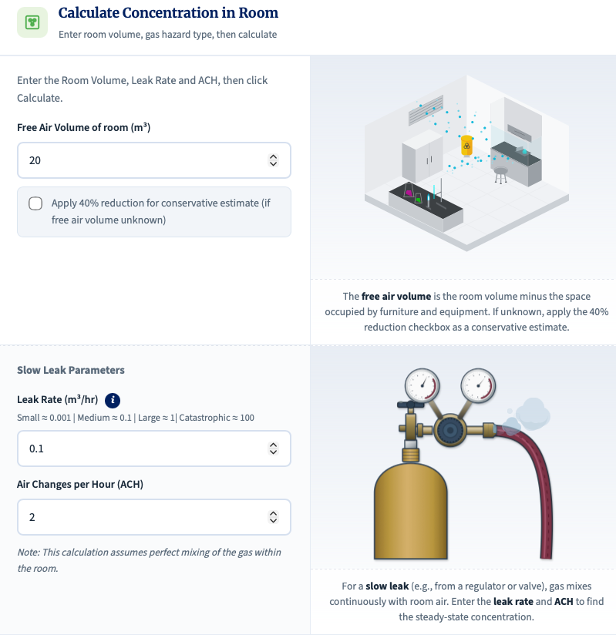
Afterwards, we selected Carbon Dioxide as the Gas Hazard Type, and then click “Calculate Concentration”.
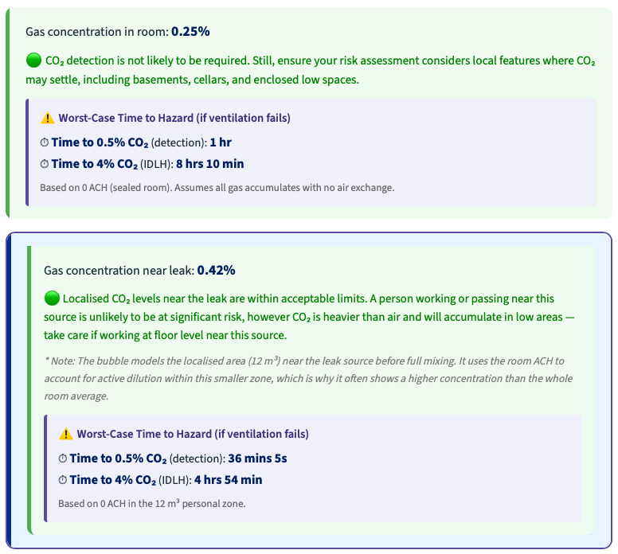
The steady-state concentration in the room is given as 0.25%, and therefore the risk after gaseous equilibration is considered to be low.
However, in the event of a full ventilation failure, the gas would build in the room as the potential for the air to be replaced is heavily reduced. In this instance, the calculator will provide a “Time to Hazard”, and for the room it is indicated that the time to reach a threshold in which detection would alert would be roughly 1hr. At this point in time, users will have been exposed to excess CO2, but not in concentrations high enough to cause significant symptoms.
If we review the generated report, it can also provide an indication of the detection type that might have been necessary, although this calculation does not indicate that this is a recommendation. In instances where detection would be needed, the guidance would indicate that an NDIR CO2 sensor would be necessary, and it be mounted towards the ground at about 300mm above floor height.
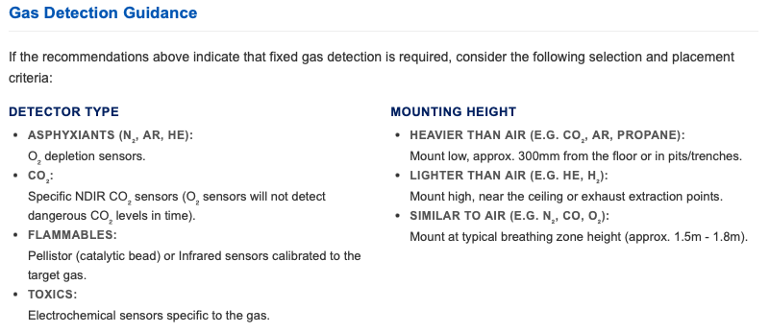

Scenario 8: Mixed Gas Cylinders & Multiple Independent Risks
Answer:
Gas Volume: 9.87 m³. (Calculated using 200 bar × 50L).
CO₂ Hazard: The CO₂ gas volume is 0.987 m³ (10% of total). This results in an extreme room CO₂ concentration of 3.29% (approaching the 4% IDLH threshold).
Hydrogen Hazard: The H₂ gas volume is 0.987 m³ (10% of total). This results in a room H₂ concentration of 3.29% (above the 1% / 25% LEL detection threshold).
Oxygen Depletion: The total gas release (9.87 m³) displaces air, resulting in a lethal room O₂ concentration of 14.06%.
Detector Strategy: While all three hazards are independently lethal/explosive at a full room release, they do not trigger alarms at the same time. The CO₂ detector alarm threshold is 0.5%, requiring only 1.5 m³ of the mixed gas to leak. The Hydrogen 25% LEL alarm threshold is 1%, requiring 3.0 m³ of mixed gas to leak. The Oxygen 19.5% depletion alarm requires 2.0 m³ of mixed gas to leak to displace enough air.
Recommendation: Because the gases travel as a plume, it is recommended to install a CO₂ detector in the breathing zone. This is because the density of the plume is similar to air, and the threshold for CO2 is the lowest, and will therefore alarm first.

Explanation:
For calculations with mixed gases, knowledge of the hazards is required as this will allow you to determine which calculations need to be run.
For this scenario, we have a cylinder that contains 50L of gas, and that mixture comprises 10% CO2, 10% H2 and 80% N2. CO2 is primarily toxic before it is an asphyxiant, H2 is flammable and can cause asphyxiation, and N2 is an asphyxiant, so we have a variety of hazards to consider.
We start off by calculating the volume of the cylinder. We can go to the BOC website and find out that a K sized cylinder for this gas mix contains 9.67m3 of gas.
We can calculate individual gas volumes by simply referring to the mole fractions of the gas in the cylinder. Nitrogen is 80% of the mixture, and is therefore 7.74m3 of gas, and CO2 and H2 are both 10% each of the mixture, and therefore there will be 0.967m^3 of each in the cylinder.
In theory, as each of the gases is an asphyxiant, we can calculate the oxygen depletion risk using the full volume of the cylinder. We know everything we need to know already, and therefore we can use the “I have a gas cylinder and already know the volume of the contents.” option.
We populate the fields, and ensure we are calculating the Asphyxiation risk.
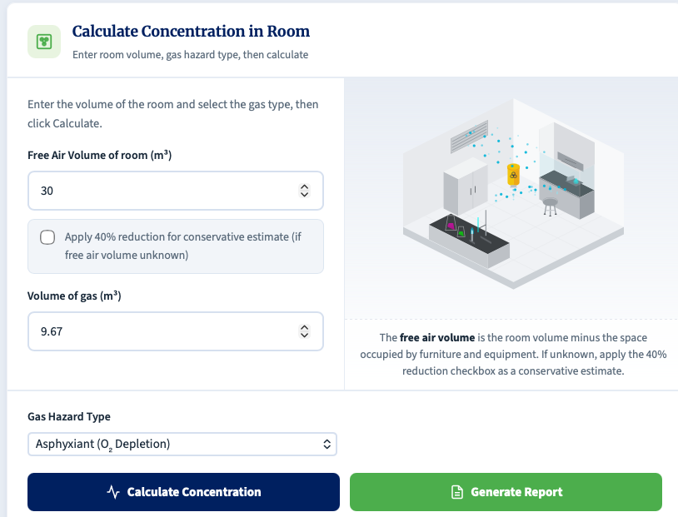
This yields a value of 14.2% O2 concentration, indicating that there is a high risk of asphyxiation.
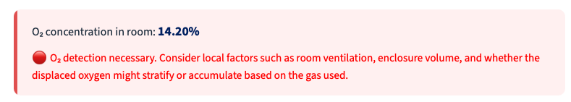
Continuing on, we look at the CO2 enrichment risk first.
We do the same calculation again, but this time we use the CO2 concentration deduced above (0.967m3), and we select the Carbon Dioxide option – then Calculate.
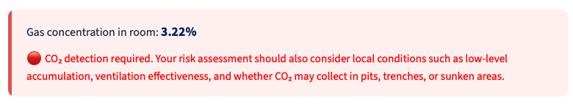
Similarly, this indicates we have the potential to create a hazardous environment in the event of a catastrophic release.
Lastly, we consider the H2 risk. H2 is a highly flammable substance, so we perform the same calculation once more using a volume of 0.967m3, but we select Flammable as the Gas Hazard Type.
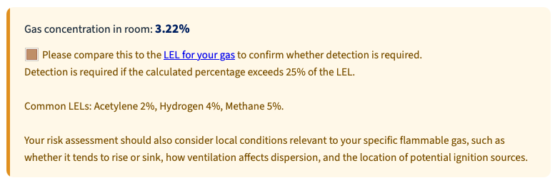
In this instance, we are at 3.22%, which is exceeds 25% of the LEL for H2 (1%).
As we can see, all three of the identified risks have the potential to cause a risk to safety, and all for different reasons.
In reality, these gases all behave slightly differently. H2 will rise rapidly, CO2 will sink towards the floor, and N2 will collect in the breathing zone. Does that mean we need three detectors?
Then simple answer is no. Thermodynamics dictates that the monitor should be selected based on the risk, and the height should be selected based upon the collective property of the gas.
The gas will travel as a plume during a release event, and the density for this gaseous mixture, as a result of it being mostly Nitrogen, will be similar, but slightly lighter than air. With that in mind, the one should determine which detector is likely to alert first, and then select based on that.
In this instance, CO2 has the lowest concentration to trigger the alarm, and therefore the best plan of action would be to install a CO2 detector in the breathing zone, as this has the highest likelihood of alerting early.

Gas/Cryogen Safety Calculator: Mathematical Models

This document outlines the theoretical models and formulas utilized by the Gas/Cryogen Safety Calculator, based on the methodology detailed in example questions.

1. Volume Calculations

Before any concentration can be determined, the total volume of gas (measured at standard atmospheric pressure and temperature) must be calculated from the initial source parameters.

1.1 Compressed Gas Volume

This calculation is approximated using Boyle's Law (P1V1 = P2V2), assuming constant temperature, expanding the cylinder's internal capacity to standard atmospheric pressure.

$$V_{gas}=\frac{P_{cyl}×\left(\frac{V_{water}}{1000}\right)}{1.013}$$

Where:

V_gas = Total expanded volume of the gas (m³)

P_cyl = Initial pressure of the cylinder (bar)

V_water = Water capacity of the cylinder (Litres)

1000 = Conversion factor (Litres to m³)

1.013 = Standard atmospheric pressure (bar)

1.2 Liquefied Gas Volume

A direct mass-to-volume conversion using the specific volume of the gas at standard conditions.

$$V_{gas}=W×SV$$

Where:

V_gas = Total expanded volume of the gas (m³)

W = Weight of the liquefied contents (kg)

SV = Specific Volume of the specific gas (m³/kg)

1.3 Cryogenic Gas Volume

Utilizes standard liquid-to-gas expansion ratios.

$$V_{gas}=\frac{V_{liquid}×E_{R}}{1000}$$

Where:

V_gas = Total expanded volume of the gas (m³)

V_liquid = Volume of the cryogenic liquid (Litres)

E_R = Expansion Ratio (e.g., 694 for Liquid Nitrogen, 757 for Liquid Helium)

1000 = Conversion factor (Litres to m³)

2. Room Concentration (Instantaneous Release)

This model assumes a catastrophic failure where the entire container contents are released immediately and mix perfectly into the room.

2.1 General / Flammable / CO₂ Concentration (%)

$$C_{\backslash \%}=\left(\frac{V_{gas}}{V_{room}}\right)×100$$

Where:

C_% = Resulting concentration of the gas in the room (%)

V_gas = Total expanded volume of the gas (m³)

V_room = Free air volume of the room (m³)

2.2 Toxic Gas Concentration (ppm)

$$C_{ppm}=\left(\frac{V_{gas}}{V_{room}}\right)×1,000,000$$

Where:

C_ppm = Resulting concentration of the gas in the room (parts per million)

2.3 Oxygen Deficiency (Asphyxiant Concentration)

This calculation assumes that the gas released from the cylinder forces an equivalent volume of perfectly mixed 'normal air' out of the room. It assumes normal clean air contains exactly 20.95% oxygen by volume in an instantaneous release.

$$O_{2\backslash \%}=\left(\frac{\left(V_{room}-V_{gas}\right)×0.2095}{V_{room}}\right)×100$$

Where:

O2_% = Resulting oxygen concentration in the room (%)

0.2095 = Standard volume fraction of oxygen in normal air (20.95%)

2.4 Oxygen Enrichment

This calculates the concentration when pure oxygen is released into a room, accounting for the displacement of standard room air (assumed 21% baseline for this specific calculation).

$$O_{2\backslash \%}=\left(\frac{\left(V_{room}×0.21\right)+V_{gas}-\left(0.21×V_{gas}\right)}{V_{room}}\right)×100$$

3. Continuous Slow Leak (Steady-State)

This models a steady leak into a room with active ventilation. Based on a simplified steady-state mass balance equation, the room reaches 'steady state' when the rate of the hazardous gas entering exactly equals the rate of mixed air extracted.

3.1 Ventilation Rate (Q)

$$Q=V_{room}×ACH$$

Where:

Q = Volumetric flow rate of ventilation (m³/hr)

ACH = Air Changes Per Hour (hr⁻¹)

3.2 General / Flammable / CO₂ Concentration (%)

$$C_{\backslash \%}=\left(\frac{L}{Q}\right)×100$$

Where:

L = Leak Rate of the gas into the room (m³/hr)

3.3 Toxic Gas Concentration (ppm)

$$C_{ppm}=\left(\frac{L}{Q}\right)×1,000,000$$

3.4 Oxygen Deficiency (Asphyxiants)

Calculates the depressed equilibrium of oxygen levels (using a 20.9% baseline).

$$O_{2\backslash \%}=20.9×\left(1-\frac{L}{Q}\right)$$

3.5 Oxygen Enrichment

Calculates the elevated equilibrium of oxygen levels (using a 20.9% baseline).

$$O_{2\backslash \%}=20.9+\left(\frac{L}{Q}×100\right)$$

4. Worst-Case Time to Hazard (0 ACH)

This calculates the time required to reach a dangerous threshold if all building ventilation completely fails, essentially creating a sealed box.

4.1 Oxygen Deficiency (Time to 19.5% and 18%)

Utilizes a logarithmic decay function to find when the oxygen level drops to specific warning and danger thresholds.

Time to 19.5% (Warning Level):

$$t_{19.5}=\left(\frac{V_{room}}{L}\right)×\ln\left(\frac{20.9}{19.5}\right)$$

Time to 18.0% (Danger Level):

$$t_{18.0}=\left(\frac{V_{room}}{L}\right)×\ln\left(\frac{20.9}{18.0}\right)$$

Where:

t = Time required to reach the target concentration (hours)

ln = Natural logarithm

4.2 Gas Concentration (Time to 0.5% and 4% CO₂)

Utilises a logarithmic accumulation function for gases displacing room air.

Time to 0.5% (Detection/Warning):

$$t_{0.5}=-\left(\frac{V_{room}}{L}\right)×\ln\left(1-0.005\right)$$

Time to 4.0% (IDLH limit):

$$t_{4.0}=-\left(\frac{V_{room}}{L}\right)×\ln\left(1-0.04\right)$$

4.3 Oxygen Enrichment (Time to 23.5%)

Calculates the time until standard air is enriched to the critical 23.5% threshold.

$$t_{23.5}=-\left(\frac{V_{room}}{L}\right)×\ln\left(\frac{100-23.5}{100-20.9}\right)$$

4.4 Flammable / Toxic Linear Accumulation

Because standard exposure limits (LEL and WEL) vary drastically by specific gas, the calculator outputs a linear accumulation rate per hour for the user to compare against their specific gas limits.

Flammable Rate (% per hour):

$$Rate_{\backslash \%}=\left(\frac{L}{V_{room}}\right)×100$$

Toxic Rate (ppm per hour):

$$Rate_{ppm}=\left(\frac{L}{V_{room}}\right)×1,000,000$$

5. Personal Bubble Assessment

A secondary calculation applied simultaneously to all scenarios to estimate the localized concentration immediately surrounding the leak.

Mechanism: It uses the exact same equations outlined in Sections 2, 3, and 4.

Variable Substitution: The room volume (V_room) is strictly replaced with 12 (representing an arbitrary 12 m³ workspace / 2 x 2 x 3 m zone).

Ventilation: For slow leaks, the ventilation rate (Q) becomes 12 x ACH.

2. Key Assumptions Built into the Calculator
The calculator relies heavily on idealized scenarios to provide a functional, conservative estimate for basic risk assessment purposes.
Perfect Mixing (Uniform Dispersion): The core assumption of almost all basic gas calculators. It assumes that upon release, the gas instantly and perfectly mixes with the air in the specified volume (either the whole room or the Personal Bubble), creating a homogenous atmosphere.
Ideal Gas Behaviour: Calculations for compressed gas volume ignore the compressibility factor (Z-factor) of real gases. While Boyle's Law provides a close and computationally simple estimate, real gases deviate from ideal behaviour at very high pressures.
Complete Displacement Mechanics: The asphyxiant calculation assumes the released gas forces an equivalent volume of perfectly mixed 'room air' out of the space, rather than displacing pure oxygen or creating a highly pressurized vessel.
Isothermal Conditions: The calculations assume the gas release does not drastically drop the room temperature. In reality, large releases (especially of cryogens or rapidly expanding compressed gases) will significantly lower the room temperature due to the Joule-Thomson effect and latent heat of vaporization.
Room Free Volume: The calculator offers a simple '40% reduction' toggle for cluttered rooms. This is an arbitrary (though conservatively safe) blanket estimate of the physical space occupied by benches, analytical equipment, and cabinets, used when precise free-volume measurements are unavailable.

3. Known Flaws, Limitations, and Defence of the Approach
When defending or justifying the use of this calculator, it is crucial to clearly acknowledge its limitations. It is designed solely as a screening tool for worst-case scenarios, not a complex Computational Fluid Dynamics (CFD) simulator.

Limitation 1: Ignoring Gas Stratification & Buoyancy
The Flaw: By assuming 'perfect mixing', the calculator severely underestimates local hazards from heavy or light gases.
The Reality: Cold gases (like cryogens), heavy gases (like Carbon Dioxide and Argon), and LPG will pool on the floor and fill a room from the bottom up. Light gases (like Hydrogen or Helium) will rapidly rise and pool at the ceiling.
The Impact: If 1m³ of CO₂ is released into a 10m³ room, the calculator shows a 10% average concentration. In reality, the concentration at floor level might be 100% (lethal), while at ceiling height it might be near 0%. The calculator may report a 'safe' average when a lethal pocket exists. Therefore, users must be trained to consider the specific gravity of the gas when placing detectors or interpreting results.

Limitation 2: The 'Personal Bubble' is a Rigid Construct
The Flaw: The 12 m³ bubble provides a useful localized proximity warning, but the fixed volume is arbitrary.
The Reality: Fluid dynamics dictate that a high-pressure jet release from a sheared valve might shoot straight past a person, while a slow, heavy leak from a regulator might pool silently around their feet without mixing into a 12 m³ zone.
The Impact: The bubble calculation attempts to bridge the gap between 'perfect mixing' and 'stratification' by forcing a smaller arbitrary mixing zone, but it does not account for the physical mechanics (momentum, jet dispersion) of the specific release.

Limitation 3: High-Pressure Non-Ideality
The Flaw: Using Boyle's law without the Z-factor for cylinders compressed to 200-300 bar slightly underestimates the total gas volume.
The Reality: Gases like Nitrogen or Argon are less compressible at high pressures. A 50L cylinder at 230 bar actually holds slightly more physical gas molecules than the simple (230 × 50)/1.013 formula would suggest.
The Impact: For general risk screening, this error is usually acceptable (often less than 5-10% deviation), but it means the volume calculation is not strictly chemically accurate for high-pressure industrial cylinders. Incorporating Z-factors would require gas-specific non-linear lookups, overcomplicating a screening tool.

Limitation 4: Ventilation Short-Circuiting
The Flaw: In the slow leak calculation, the formula Q = V × ACH assumes the ventilation perfectly clears the homogeneously mixed air.
The Reality: In many laboratories, fresh air from a ceiling supply grille may flow directly into a ceiling extract grille without properly turning over the air at floor level (known as short-circuiting).
The Impact: The steady-state concentration calculation could dangerously underestimate the risk if the ventilation is mechanically ineffective in the specific area where the leak occurs or where the gas pools.

Conclusion for Defence & Justification
The calculator is highly defensible provided its scope is clearly defined and communicated to users. It is a conservative, mathematical first-pass screening tool designed to trigger the implementation of further controls (such as fixed gas detection or mechanical ventilation upgrades) by modelling idealized worst-case scenarios.
It cannot—and does not attempt to—replace a competent person considering the specific physics, specific gravity, geometry, and ventilation dynamics of a laboratory space. Results should always be used to guide a formal risk assessment, never to bypass one.

